Project Report Template

**1.INTRODUCTION**

**1.1 Overview :**

OVER the last twenty years, air travel has been increasingly preferred among travelers, mainly because of its speed and in some cases comfort. This has led to phenomenal growth in air traffic and on the ground. An increase in air traffic growth has also resulted in massive levels of aircraft delays on the ground and in the air. These delays are responsible for large economic and environmental losses. According to, taxi-out operations are responsible for 4,000 tons of hydrocarbons, 8,000 tons of nitrogen oxides and 45,000 tons of carbon monoxide emissions in the United States in 2007. Moreover, the economic impact of flight delays for domestic flights in the US is estimated to be more than $19 Billion per year to the airlines and over $41 Billion per year to the national economy In response to growing concerns of fuel emissions and their negative impact on health, there is active research in the aviation industry for finding techniques to predict flight delays accurately in order to optimize flight operations and minimizedelays.

Using a machine learning model, we can predict flight arrival delays. The input to our algorithm is rows of feature vector like departure date, departure delay, distance between the two airports, scheduled arrival time etc. We then use decision tree classifier to predict if the flight arrival will be delayed or not. A flight is delayed when difference between scheduled and actual arrival times is greater than 15 minutes. Furthermore, we compare decision tree classifier with logistic regression and a simple neural network for various figures of merit. Finally, it will be integrated to web based application

**1.2 Purpose:**

There are plenty of other reasons why passengers face flight delays, such as time for fueling, boarding passengers, aircraft cleaning, etc. Airlines allow for a little bit of flexibility, and it's important for passengers to understand such so they can fit some flexibility into their schedule, too.

**BENIFIDE:**

* **Flight delays can improve airline operations and passenger satisfaction.**
* **The airline should provide an option of taking an alternate flight or a complete refund to the passengers.**
* **Time increase heavy dension.**

**2.PROBLEM DEFENITION&DESIGN THINKING**

**2.1 EMPATHY MAP:**

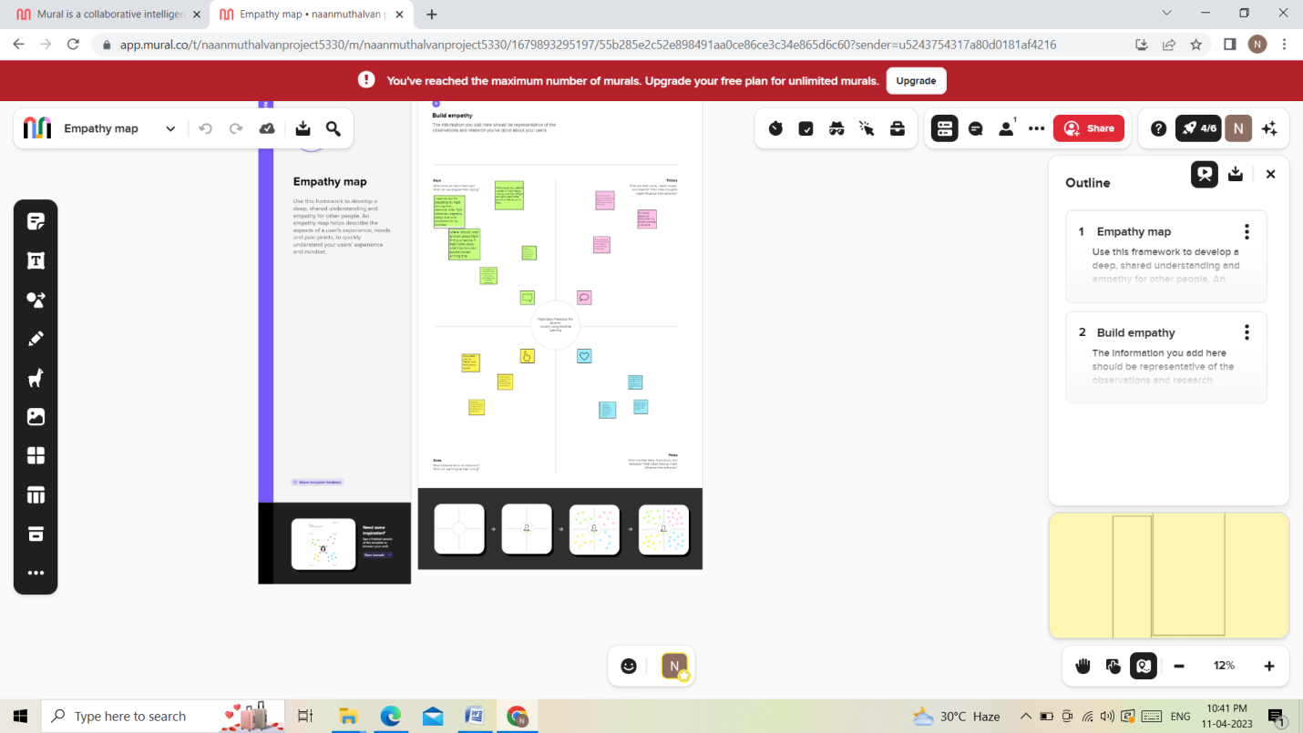

**2.2 IDENDIFICATION&BRAINSTROMING:**

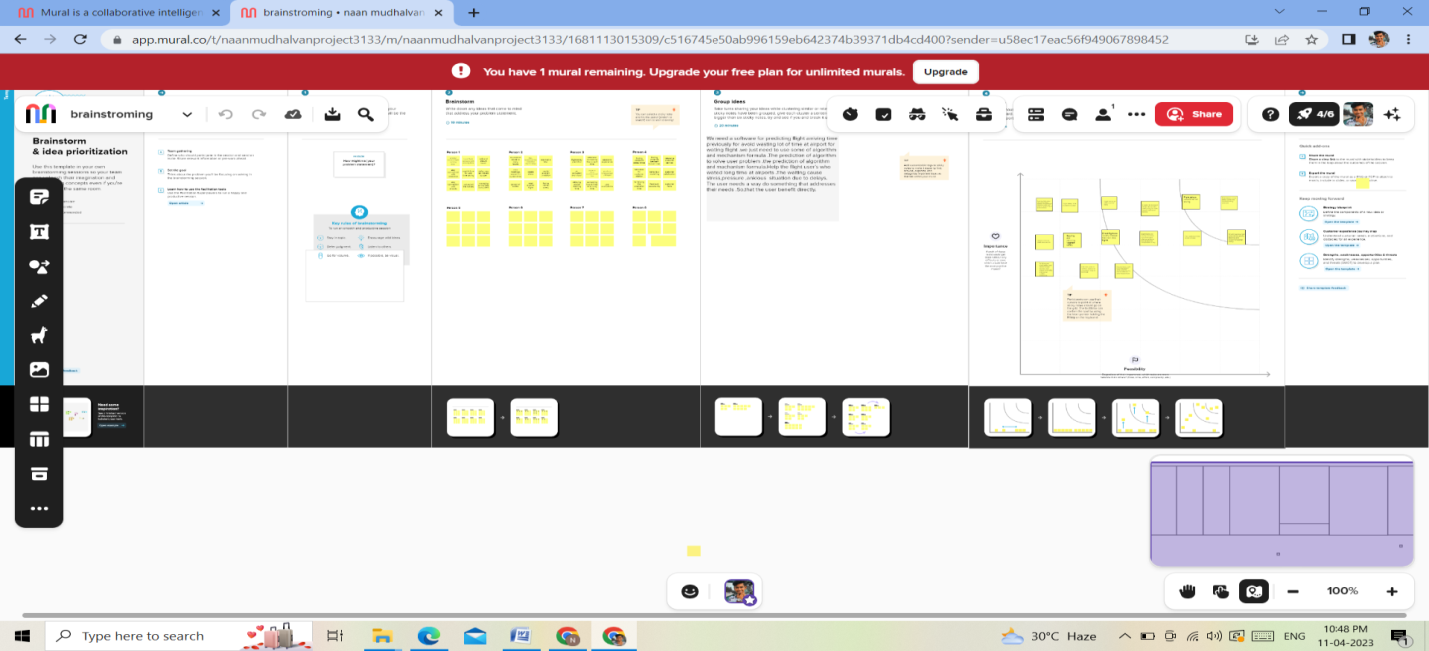

**3.RESULT:**

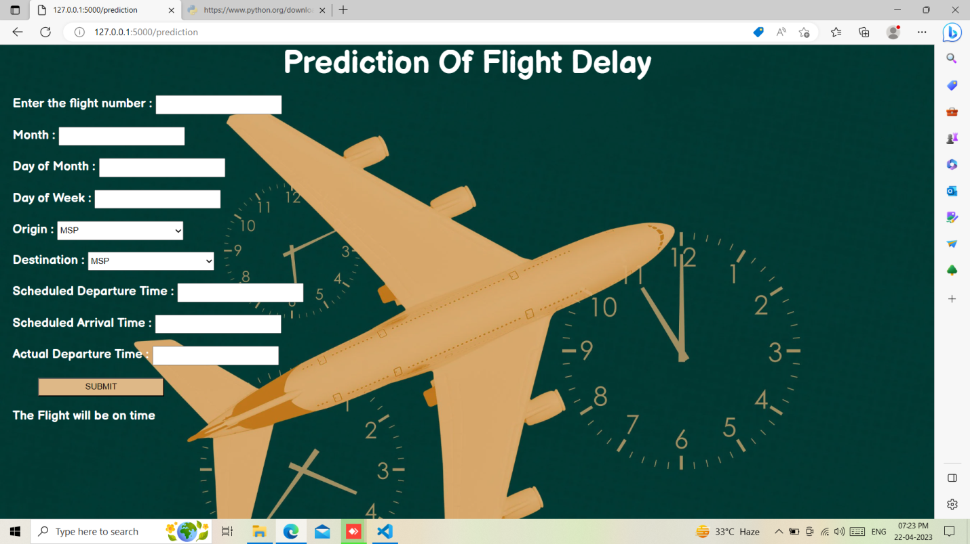

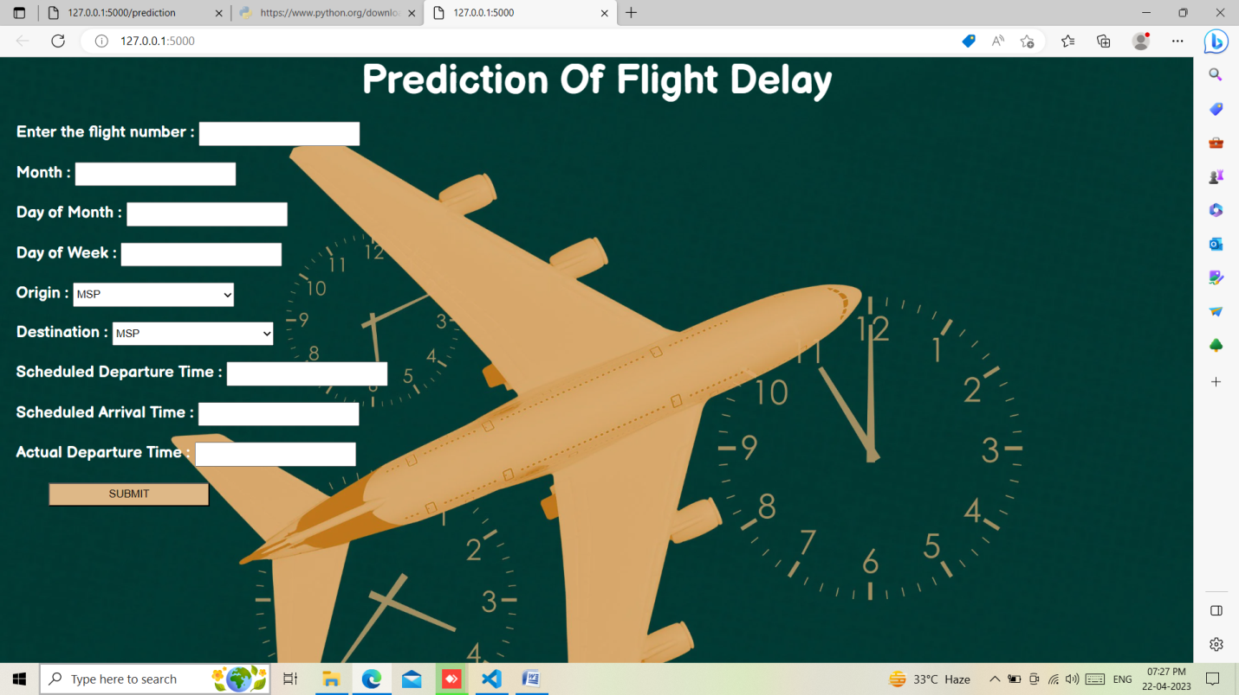

**4.ADVANTAGES & DISADVANTAGES**

**4.1.ADVANTAGES:**

* **Even if it is at the airport you can enjoy your holiday destination for a little longer.**
* **Enjoy the local food write and send a holiday card from the airport or sit back and relax and enjoy the vibrant life at the airport.**
* **That wait that comes with a flight delay can last long luckily in case of a delay of two hours or more or with delay due to exceptional circumstances.**
* **Food and drinks should be provided by the airline usually by vouchers.**
* **Including the transport to the accommodation.**

**4.2.DISADVANTAGES:**

* **Flight delays not only irritate air passengers and disrupt their schedules but also cause a decrease in efficiency ,an increase in capital costs ,reallocation of flight crews and aircraft ,and additional crew expenses.**
* **Bad weather conditions airport congestion airspace congestion and use of smaller aircraft by airlines.**

**5.APPLICATIONS :**

**An airline is a company that provides air transport services for traveling passengers and/or freight. Airlines use aircraft to supply these services and may form partnerships or alliances with other airlines for code share agreements, in which they both offer and operate the same flight.**

**6.CONCLUSION:**

**Predicting flight delays is on interesting research topic and required many attentions these years. Majority of research have tried to develop and expand their models in order to increase the precision and accuracy of predicting flight delays. Since the issue of flights being on-time is very important, flight delay prediction models must have high precision and accuracy. In this study, we proposed a novel optimized forecasting model based on deep learning which engages LM algorithm. Afterwards, two other structures are created to study and validate the positive effect of denoising autoencoder and LM algorithm, which one has deleted denoising autoencoder and the other has omitted LM algorithm. Moreover, we have imbalanced dataset which should be balanced. We used undersampling and upsampling technique to balance the data. However, results show that upsampling leads to overfitting. Therefore, under sampling is used for balancing.**

**7.FUTURE SCOPE:**

**Predicting flight delays is on interesting research topic and required many attentions these years. Majority of research have tried to develop and expand their models in order to increase the precision and accuracy of predicting flight delays. Since the issue of flights being on-time is very important, flight delay prediction models must have high precision and accuracy. In this study, we proposed a novel optimized forecasting model based on deep learning which engages LM algorithm. Afterwards, two other structures are created to study and validate the positive effect of denoising autoencoder and LM algorithm, which one has deleted denoising autoencoder and the other has omitted LM algorithm. Moreover, we have imbalanced dataset which should be balanced. We used under sampling and up sampling technique to balance the data. However, results show that up sampling leads to over fitting. Therefore, under sampling is used for balancing**.

**8.APPENDIX**

**SOURCE CODE**

**Python:**

from flask import Flask, render_template, request

import pickle

import numpy as np

infile = open(r'D:\ML\Flight Delay Prediction Using Machine Learning\Training\flight.pkl', 'rb')

model = pickle.load(infile)

app = Flask(__name__)

@app.route('/')

def home():

    return render_template("index.html")

@app.route('/prediction', methods =['POST'])

def predict():

    name = request.form['name']

    month = request.form['month']

    dayofmonth = request.form['dayofmonth']

    dayofweek = request.form['dayofweek']

    origin = request.form['origin']

    if(origin == "msp"):

        origin1,origin2,origin3,origin4,origin5 = 0,0,0,0,1

    if(origin == "dtw"):

        origin1,origin2,origin3,origin4,origin5 = 1,0,0,0,0

    if(origin == "jfk"):

        origin1,origin2,origin3,origin4,origin5 = 0,0,1,0,0

    if(origin == "sea"):

        origin1,origin2,origin3,origin4,origin5 = 0,1,0,0,0

    if(origin == "atl"):

        origin1,origin2,origin3,origin4,origin5 = 0,0,0,1,0

    destination = request.form['destination']

    if(destination == "msp"):

        destination1,destination2,destination3,destination4,destination5 = 0,0,0,0,1

    if(destination == "dtw"):

        destination1,destination2,destination3,destination4,destination5 = 1,0,0,0,0

    if(destination == "jfk"):

        destination1,destination2,destination3,destination4,destination5 = 0,0,1,0,0

    if(destination == "sea"):

        destination1,destination2,destination3,destination4,destination5 = 0,1,0,0,0

    if(destination == "atl"):

        destination1,destination2,destination3,destination4,destination5 = 0,0,0,1,0

    dept = request.form['dept']

    arrtime = request.form['arrtime']

    actdept = request.form['actdept']

    dept15 = int(dept)-int(actdept)

    total = [[name, month, dayofmonth, dayofweek, origin1,origin2,origin3,origin4,origin5, destination1,destination2,destination3,destination4,destination5, int(arrtime),dept15]]

    #print(total)

    y_pred = model.predict(total)

    print(y_pred)

    if(y_pred == [0.]):

        ans = "The Flight will be on time"

    else:

        ans ="The Flight will be delayed"

    return render_template("index.html", name=ans)

if __name__ == '__main__':

    app.run()

**SCREENSHOTS**

